Nigeria Crude Oil Market Intelligence Analysis
Nigeria Crude Oil Documentation
An Interactive Power BI Analysis of Price, Production, Exports, Growth, Relationships and Market Anomalies

Project Attribute | Details
Project Type | Data Analytics / Business Intelligence
Tools | Microsoft Excel, Power BI, DAX
Data Frequency | Monthly
Coverage | January 2006 – July 2026
Observations | 247 months
Geographic Focus | Nigeria

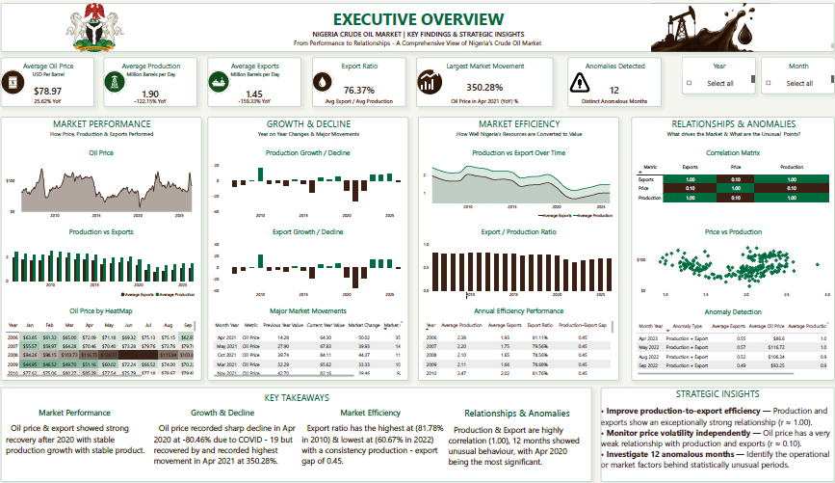

Table of Contents
- 1. Executive Summary
- 2. Business Context
- 3. Business Problem
- 4. Dataset Description
- 5. Data Quality Assessment
- 6. Analytical Approach
- 7. Dashboard Architecture
- 8. Major Findings
- 9. Anomaly Analysis
- 10. Recommendations
- 11. Project Limitations
- 12. Final Business Conclusion

1. Executive Summary
This project analyses 247 months of Nigerian crude-oil market data from January 2006 to July 2026, focusing on three core indicators:
- Crude oil price — USD/barrel
- Domestic crude oil production — million barrels/day
- Crude oil exports — million barrels/day
Across the full period, the dataset records an average crude oil price of $78.97/barrel, average domestic production of 1.90 million barrels/day, and average exports of 1.45 million barrels/day.
The analysis identifies major market episodes including the 2008 price boom and collapse, the 2014–2016 oil-price decline, the 2020 COVID-19 price shock, the 2022 production collapse, and a sharp price rebound in March 2026.
The central finding is that the Nigerian crude-oil market in this dataset has two largely distinct dimensions: price behaves primarily as an externally driven market variable, while production represents a longer-term domestic supply-side story.
Same-month correlations between price and both production and exports are weak at approximately r = 0.10, whereas production and exports have a correlation of r = 1.00.
A major data-quality issue was also identified: domestic production minus exports equals exactly 0.45 million barrels/day in all 247 months. This strongly suggests that exports may have been derived from production using a fixed relationship rather than independently measured. Consequently, production and export findings must be interpreted with caution.

2. Business Context
Nigeria's crude-oil sector is highly exposed to movements in international oil prices while simultaneously facing domestic production constraints.
A high international oil price can create favourable revenue conditions, but the benefit may be constrained if domestic production falls.
This project therefore examines the interaction between Market Price → Domestic Production → Exports → Revenue Exposure, while also identifying periods where the market behaves unusually.
The analysis is designed to help users move beyond individual numbers and understand long-term trends, major market shocks, structural changes and unusual behaviour.

3. Business Problem
The project addresses the following business questions:

Market Performance
- How has Nigerian crude-oil price changed from 2006 to 2026?
- How have domestic production and exports evolved?
- What were the major market highs and lows?

Growth & Decline
- Which periods experienced the largest increases or declines?
- Which market movements were temporary shocks versus longer-term trends?

Relationships
- How strongly are oil price, production and exports related?
- Does price appear to influence production over subsequent months?

Anomalies
- Which months exhibited unusual market behaviour?
- What were the most significant market shocks?

Decision Support
- What areas should receive management or policy attention based on the evidence?

4. Dataset Description
The dataset contains monthly observations covering January 2006 through July 2026.
Variable | Description | Unit
tyear | Year | Year
tmonth | Month | Month
period | Year-month period | Date/Period
crudeOilPrice | Crude oil price | USD/barrel
domProd | Domestic crude oil production | Million bbl/day
crudeOilExp | Crude oil exports | Million bbl/day
The dataset contains 247 monthly observations with no missing observations across the analysed variables. The overall averages are $78.97/barrel for price, 1.90 million bbl/day for production and 1.45 million bbl/day for exports.

5. Data Quality Assessment
Before conducting the analysis, the dataset was assessed for structural and analytical quality.

Checks performed
- Missing-value assessment
- Duplicate-record assessment
- Date continuity
- Duplicate year-month combinations
- Positive-value validation
- Period consistency
- Relationship checks between variables
- Outlier/anomaly investigation

Key Data Quality Finding
The most important issue discovered was the relationship between production and exports.
Domestic Production − Exports = 0.45 million bbl/day across all 247 months
As a result, Production ↔ Exports correlation = 1.00.
This is unlikely to represent two completely independent real-world measurements. The analysis therefore flags the possibility that the export variable was derived from production using a fixed formula.

Portfolio implication
Rather than hiding the issue, the analysis demonstrates that data-quality validation can change how analytical findings should be interpreted. The project does not claim that the 1.00 correlation proves an operational relationship between independently measured production and exports.

6. Analytical Approach

01 — Market Performance
- Average price
- Average production
- Average exports
- Export/production ratio
- Historical trends
- Annual performance

02 — Growth & Decline
- Year-over-year movements
- Growth periods
- Declining periods
- Major market movements
- Largest percentage changes

03 — Production–Export Relationship
- Production versus exports
- Export/production ratio
- Production-export gap
- Annual relationship

04 — Relationships
- Price vs production
- Price vs exports
- Production vs exports
- Same-month correlations
- Lagged price-production relationships

05 — Anomaly Detection
- Statistical deviations from historical behaviour
- Unusual price movements
- Unusual production movements
- Unusual export movements
- Distinct anomalous months

7. Dashboard Architecture
Page | Purpose
1. Executive Overview | High-level market position and key findings
2. Market Performance | Historical price, production and export trends
3. Growth & Decline Analysis | Major increases, declines and market movements
4. Production–Export Relationship | Relationship between physical output and exports
5. Relationships & Anomalies | Correlations, scatter analysis and unusual periods
The structure allows the user to move from Executive Summary → Performance → Change → Relationship → Investigation rather than placing every analysis on a single dashboard.
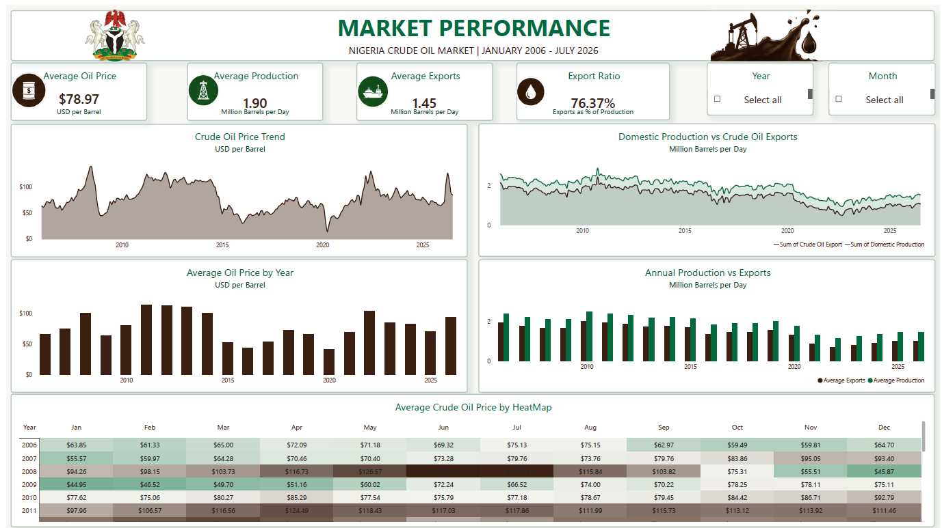
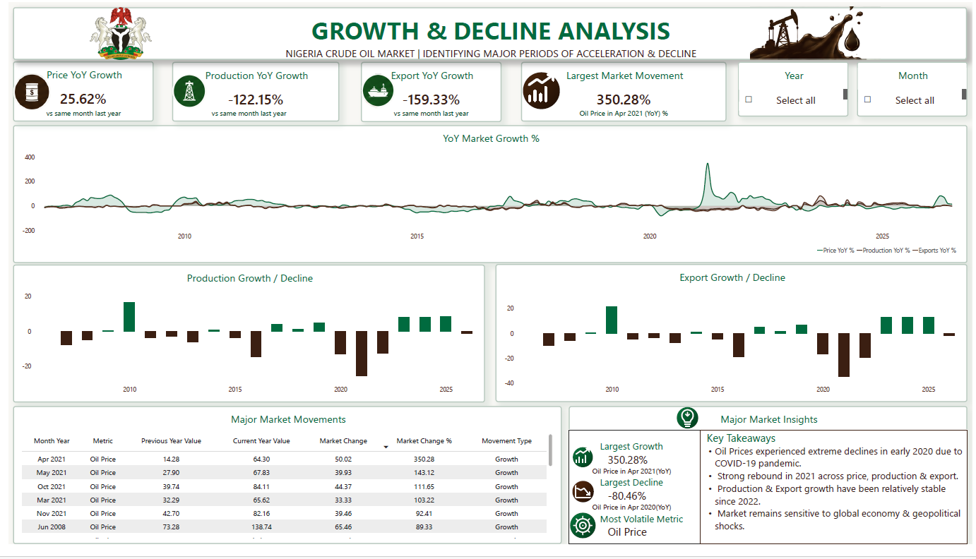
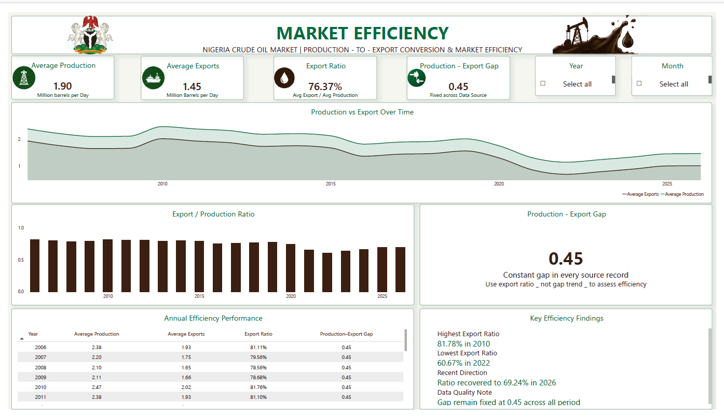
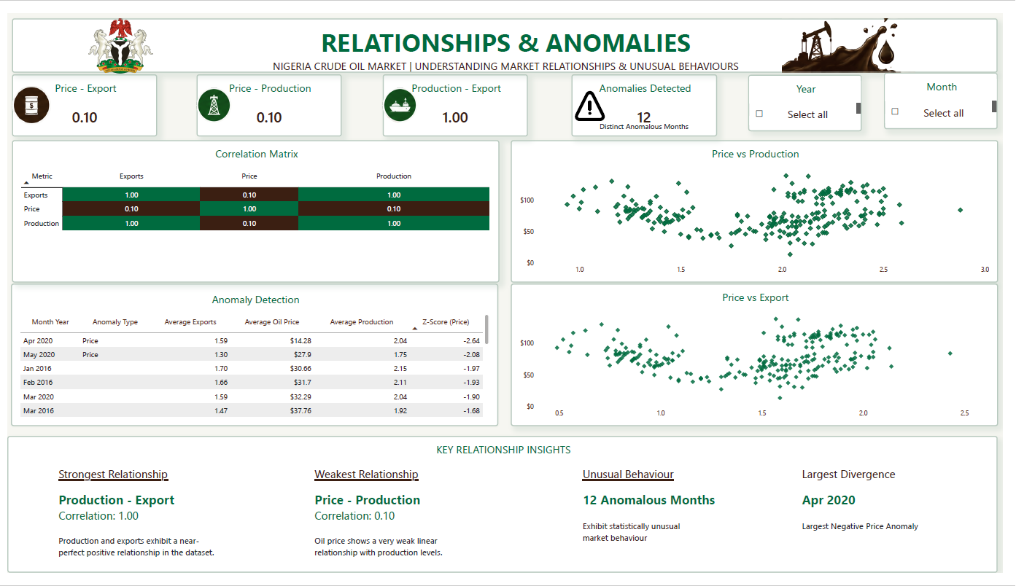

8. Major Findings

Finding 1 — Oil price experienced significant external shocks
The dataset contains several major price episodes. Price reached an all-time high of $138.74/barrel in June 2008. The most extreme event occurred in April 2020, when price fell to $14.28/barrel, representing a 55.8% monthly decline.

Finding 2 — Production has undergone a substantial long-term decline
Domestic production and exports reached historical highs in October 2010 at 2.88 and 2.43 million bbl/day respectively. Both subsequently experienced a broad downward trend, particularly after 2015.

Finding 3 — Production and exports effectively behave as one variable
The correlation between production and exports is r = 1.00. The constant 0.45 million bbl/day gap means changes in production are mirrored almost exactly by changes in exports. This should be interpreted as a characteristic of the dataset rather than definitive proof of a real-world operational mechanism.

Finding 4 — Same-month price and production relationships are weak
Price vs production is approximately r = 0.10 and price vs exports approximately r = 0.10. A lagged relationship rises from about 0.10 at zero months to 0.21 at 12 months, but remains weak.

Finding 5 — April 2020 was the most significant price shock
April 2020 recorded $14.28/barrel, a −55.8% monthly decline and an anomaly score of approximately Z = −2.64.

Finding 6 — 2022 represented an important production crisis
Production and exports reached their lowest levels in September 2022: 0.94 and 0.49 million bbl/day respectively. The analysis links this period to widespread oil theft and pipeline vandalism reported by Nigerian industry and regulatory sources.

Finding 7 — Some large YoY movements require contextual interpretation
April 2021 recorded a roughly 350% year-over-year price increase. This is primarily a base-effect phenomenon because it was compared with the exceptionally low April 2020 price.
Analytical lesson: A large percentage change does not necessarily represent an equally large underlying improvement.

9. Anomaly Analysis
The dashboard's anomaly methodology identifies 12 distinct anomalous months using the ±2 standard-deviation threshold.
The analysis also identified 62 months where price increased while production declined, showing that domestic output and global price movements frequently diverged.
The broader report also identified eight extreme low-price months using a less stringent Z-score threshold of −1.6, including the COVID-era collapse and the 2015–2016 low-price period.

Methodology distinction
- Dashboard anomaly rule: ±2 standard deviations.
- Broader extreme-low-price screening in the report: Z < −1.6.
These thresholds should remain clearly distinguished in the final portfolio so that the methodology is transparent and defensible.

10. Recommendations

1. Prioritize production recovery and protection
The analysis indicates that domestic production has declined substantially from its earlier levels. Improving and protecting productive capacity is therefore a key area of attention.

2. Address domestic production disruptions
The 2022 production collapse demonstrates the potential impact of theft, vandalism and other supply-side disruptions. Monitoring these risks should form part of production planning.

3. Treat price risk separately
Because same-month price-production correlation is weak, domestic production management should not be treated as a direct mechanism for controlling international crude-oil prices.

4. Validate the export dataset
Before using the production/export ratio as an operational efficiency KPI, the source and calculation methodology of the export variable should be validated because of the constant 0.45 gap.

5. Strengthen market monitoring
The dashboard can be used as a monitoring framework for major price movements, production declines, anomalous periods and divergence between market indicators.

6. Add external-event data
A future version should combine the market dataset with OPEC quota changes, security incidents, pipeline disruptions and policy changes, including Petroleum Industry Act developments, to connect statistical patterns more directly to real-world events.

11. Project Limitations
- Correlation does not establish causation.
- Production and exports may not be independent measurements.
- The dataset contains only three core market variables.
- External economic and geopolitical events are not directly modelled.
- Anomaly results depend on the statistical threshold selected.
- Large YoY percentages can be distorted by extreme base periods.
- Additional lag analysis beyond 12 months would strengthen the price-production analysis.

12. Final Business Conclusion
The analysis presents a Nigerian crude-oil market characterized by high exposure to global price shocks and a persistent domestic production challenge.
The strongest price events occurred around major global disruptions, while domestic production followed a longer-term declining trajectory. At the same time, production and exports move almost perfectly together in the supplied dataset, although the constant 0.45 million bbl/day gap indicates that this relationship requires data validation before being interpreted as operational efficiency.
Key business implication
Nigeria's ability to benefit from favourable global oil prices depends not only on the price environment, but critically on its ability to maintain and recover domestic production capacity.

